Final Solution Design
Contents
Introduction 1
Design Requirements 1
Solution Architecture 2
Main Design Decisions 2
Dataset Structure and Filtering 2
Forecasting Approach 3
Handling Interrupted Sequences 4
Application Design 4
Limitations 4
Conclusion 5

Introduction
The purpose of this document is to show decisions made throughout the Formula 1 lap prediction project.
In my previous LO3 document, I analysed possible models and which ones I should use based on my criteria. During the modelling process, I testes some approaches and made some decisions based on performance, complexity and suitability for the problem.
This document focuses on what was my thought process, why I took some approaches and what I could have done better.

Design Requirements
Initial research and analysis made possible choosing which requirements I should cover for the final solution.
The main goal was to predict the next lap of a Formula 1 driver, measured in seconds, using information available at the end of a current lap.
- Use historical Formula 1 race data from 2022 to 2025.
- Predict the next lap of the same driver and race.
- Handle pit stops, interrupted racing conditions and invalid lap times.
- Avoid using future lap information as a forecasting input.
- Compare different modelling approaches against a consistent baseline.
- Evaluate prediction performance using MAE, RMSE and R².
- Present actual and predicted lap times through a simple application.
My time-series approaches required a lot of computational power, due to the fact, that I am repeating .fit() for every lap, making harder to run the model.

Solution Architecture
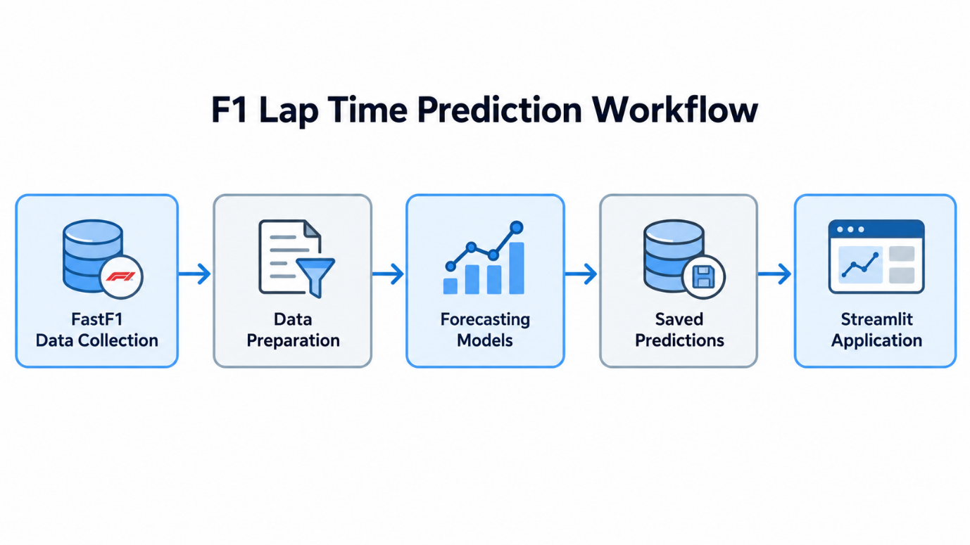

Main Design Decisions

Dataset Structure and Filtering
One of the first decisions that I had to make was how I could structure my data, clean it and prepare it, in order to make it easier for the model to predict laps and to represent a good general idea of predicting race pace.
Instead of treating every lap differently, I created pairs respecting certain rules to only represent race pace laps, so no pit stops, wrong time calculations and slow laps are selected in this pairs eligibility selection. With this check, from 101,290 lap records, I was able to get 78,236 pairs.
The target variable created was NextLapTimeSeconds.
I chose this approach, because it keeps the original race information available for further analysis and to observe patters.
Finally, I divided splits into 2022-2023 training split, 2024 validation split (optimization of the model) and 2025 test split. I used these years, because the cars did not change a lot, so lap times would be close between all these years and I had enough “clean data” to model. Using more seasons would give me way more data, but observations would differ a lot, since cars change and lap times would also change for this reason.

Forecasting Approach
Initially, I approach this problem with a regression model (Linear Regression), since the target variable was a numerical value, but after approaching some teachers, I got some feedback that even though it was a correct statement, the temporal nature of this project required a time-series forecasting for a more correct prediction and development of a model.
After this feedback, I developed a baseline using naïve-forecast to predict the next lap copying the time of the current lap. This made me able to create a really strong baseline, hard to beat and really easy for a human to understand.
I then implemented a simple exponential smoothing model and a Holt’s one, which got me the best results (metric-wise). Using optimized values of alpha=0.9 and beta=0.8, with an initial trend of zero, made me achieve greater results than the baseline.
Also I had some even better configurations, but they were to similar to the baseline and it would just be a copy of the baseline all over again.
Finally I investigated the ARIMA model, to figure out if a more complex model could give me better results. Initially, I tested ARIMA in a (1,1,0) configuration, decision made randomly, but still using information from the 08 notebook regarding the data analysis.
After this random validation split test, I used Optuna to experiment 16 more configurations (2,400 sample validation split), in order to find the optimal configuration for the ARIMA model.
ARIMA (0,1,1) was the chosen configuration as it achieved the best results, while also being different from the baseline. With this configuration, I got a small improvement, but comparing to the other models, ARIMA was the worst performing one.
A small improvement of 1.25% was made from the original baseline, below my original(illuded) target of 10%.
Model | Test MAE
Exponential Smoothing | 0.3807 s
Persistence | 0.3855 s
ARIMA(0,1,1) | 0.3900 s

Handling Interrupted Sequences
A fallback system was created for the ARIMA model when a sequence is cut due to a pit stop or any other variable outside of racing that happens. I needed a minimum of 10 previous laps for the ARIMA model to perform decently and I created a fallback system to when we don’t have this history of 10 laps, to use just the baseline. This made the ARIMA model work with 50% of the data and the other 50% of data was done with the baseline, so it is a solution found by me, maybe not the best, but a way to overcome this interruptions.

Application Design
Design Decision | Implementation
Framework | Streamlit
Navigation | 5 pages: Predictions, Evaluation, Data Sample, Methodology and Privacy
Predictions | Precomputed historical forecasts
User interaction | Select races, drivers and laps
Model execution | No model fitting during application use
Purpose | Explore predictions and compare model performance

Limitations
Design Choice | Advantage | Limitation
Univariate forecasting | Simple and efficient | No weather or tyre inputs
Lap filtering | Focus on normal race pace | Excludes race interruptions
ARIMA fallback | Handles insufficient history | Some forecasts use persistence
Saved predictions | Fast application | No new or live predictions
Exponential Smoothing | Low complexity and best MAE | Small improvement over baseline

Conclusion
Throughout this project, I learned the importance of making design decisions based on evidence rather than model complexity.
Although the initial 10% improvement target was not achieved, Exponential Smoothing provided the best results with lower computational complexity than ARIMA.
The final solution reflects the decisions, experiments and feedback received during development, helping me understand how to design a forecasting system while considering its limitations.

